Additional Guidance on Quality Control and Homogeneity Testing for the assessment for calculation of Extremes Indices with RClimDex

Carol McSweeney & John Caesar
Met Office Hadley Centre, UK.

Based upon guidance notes written for the Met Office Southeast Asian Collaboration.

1. Introduction

Each participating Met Service has already received some basic training on the use of RClimDex. In this document, we give some further guidance on the Quality Control (QC) of the data that is used for analysis.

Quality control of observational data requires a degree of personal judgement – therefore, in order to generate a dataset collaboratively, it is important to ensure that a consistent and defendable approach to QC is taken by all those undertaking analysis.

Other useful resources:
RClimDex Users Guide: http://etccdi.pacificclimate.org/software.shtml

2. Station data suitability

Firstly, decide whether the stations that you have are suitable for inclusion in this study. The stations should fulfil the following criteria:

- The record should include daily precipitation, tmin and tmax.
- The record should contain at least 30 years of data, including the standard reference period – this is normally 1971-2000, but should be agreed between participants.
- Less than 20% of the data values are missing in every year.
- The stations should be of high-quality and well maintained.
- Any historical data (metadata) about changes in location or recording equipment should be made available to the collaboration together with the data values.

If a station has been moved at any point in the recording period, or changes in the recording equipment have been made, then documentation containing data and details of the move will be required.

If you are unsure whether a station is suitable for inclusion, please contact the nominated experts who can provide further advice.

3. Inhomogeneities

Inhomogeneities or sudden ‘jumps’ or ‘steps’ in the data can occur in climate data series either as a result of a genuine step-change in climate, or as a result of changes in the way in which the data is recorded (normally a change in the station location, or the recording equipment used).

Fig 1: Example of an observed record affected by inhomogeneities. (Would be good to replace this with an example of rain or precip)

Ideally, any changes in the recording method will be recorded and this ‘metadata’ will be maintained with the station records. The discontinuity can potentially be corrected for if sufficient historical documentation is available.

If there is insufficient metadata, then it may be difficult to identify whether the step-change is a result of a real climatic shift or an artefact of changed recording methods, and we may have to exclude the station from the analysis.

We can check visually for discontinuities/step-changes in our timeseries data by making a simple timeseries plot in Excel or other plotting software. If you find that any of your stations are affected by discontinuities, please contact the nominated experts who will be able to advise on further steps to take before using this data.

4. Outliers and Errors

Outliers can appear in the data due to either genuine weather extremes, but also as a result of random recording errors. We can identify outliers using RClimDex, and examine each in turn to make a judgement on how likely it is to be an error. More obvious errors include negative precipitation amounts and cases where tmin is greater than tmax.

The first window in RClimDex asks us to set the station name, as well as for a ‘criteria (number of standard deviations)’. The default value is 3, but please set this to 4. RClimDex will identify values that lie outside 4 standard deviations of the mean of the timeseries.

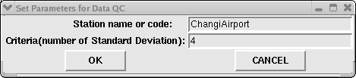

Fig 2. RClimDex screen used to set the search criteria.

The QC process in RClimDex creates a set of log files detailing potential errors. These can be examined in order to allow us to make a judgement on their likely validity. This judgement is important – we do not want to discount genuine extreme values as this can have a significant effect on the indices and trends that result from the data, so we should only eliminate values when we are very confident that they are incorrect.

The following file will have been created under the ‘log’ directory:

stationname.nastatistic.csv This file details the number of missing values in the dataset. If the series have too many missing values, RClimDex will refuse to calculate most indices.

stationname.prcpQC.csv This file lists any negative precipitation values.

stationname.tempQC.csv This file identifies errors in tmin and tmax by calculating the diurnal temperature range (DTR=tmax-tmin). DTR can be a valuable indicator of errors – i.e. negative values of DTR indicate that the recorded Tmin is greater than Tmax, which is implausible!

stationname.tepstdQC.csv This file lists the values that are outliers – they fall outside the mean± 4sd critera (the ‘low’ and ‘up’ values calculated are based on the values for each day of the year).

stationname.dtrPLOT.pdf
stationname.prcpPLOT.pdf
stationname.tmaxPLOT.pdf
stationname.tminPLOT.pdf

These files contain timeseries plots which can help us to make decisions about the likely validity of an outlying value.

Any values that we decide are likely to be errors can be changed to missing values
(-99.9). Make a copy of the original data file stationname.txt and name it stationname.QC.txt. Edit any values in the stationname.QC.txt file, and leave the original data file unaltered.

Please keep a log file of all changes made to your data. By logging the values changed, we can assess whether similar judgements were made by all of the participating individuals, and we will be able to provide evidence of this if questioned by reviewers. A template log file can be provided, and should look like figure 3. Name this file ‘stationname.QClog.xls’.

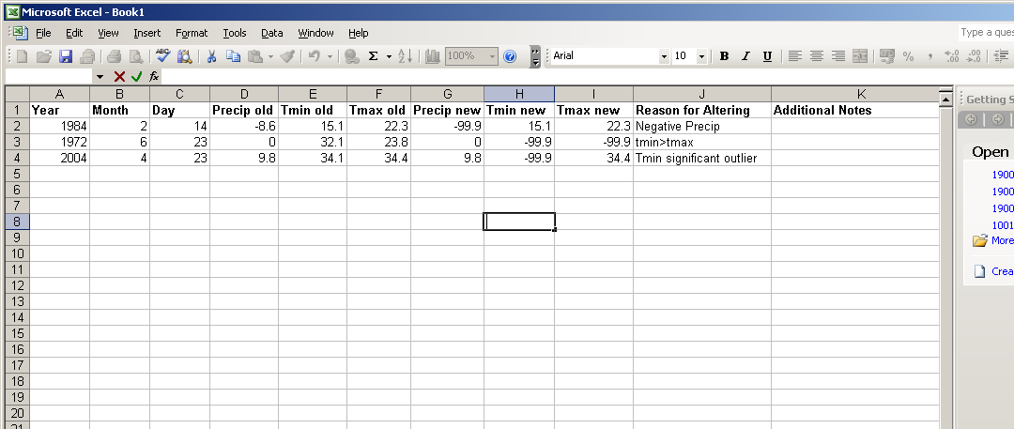

Fig 3: Example excel file in which QC edits can be logged.

Actions:

1.) Precipitation Errors

Change any negative precipitation values to missing (-99.9) (listed in stationname.prcpQC.csv). Check stationname.prcpPLOT.pdf for precipitation values that are unrealistically large.

2.) Negative DTR

Change both Tmin and Tmax to missing (-99.9) where the DTR is negative.

3.) Outliers

Check all the listed outlying values. Many of these values listed will be valid. It is only necessary to edit values that are clearly erroneous. Values can be checked in the files stationname.tmaxPLOT.pdf, stationname.tminPLOT.pdf and stationname.dtrPLOT.pdf.

An example is given below. The following table lists the contents of stationname.tepstdQC.csv for one station. This file list the recorded value for values identified as outliers, as well as the ‘up’ and ‘low’ values which are calculated from the multi-annual mean and standard deviation for each day of the year. In this example, most of the recorded values do not lie much beyond the ‘up’ and ‘low’ values. The tmin value recorded on 23/4/2004, however, is significantly outside these bounds. We can examine this value in the stationname.tminPLOT.pdf file, and see that it is very far outside the range of recorded values and almost certainly an error. The other values listed are considered to be plausible and are unchanged.

year | month | day | tmaxlow | tmax | tmaxup | tminlow | tmin | tminup | dtrlow | dtr | dtrup
1965 | 8 | 16 | 26.67 | 25.2 | 40 | 20.63 | 20.7 | 28.69 | 3.07 | 4.5 | 14.33
1968 | 3 | 27 | 26.26 | 25.1 | 43.75 | 19.3 | 23.9 | 28.02 | 1.92 | 1.2 | 20.77
1970 | 12 | 5 | 21.04 | 28.1 | 37.93 | 17.71 | 17.4 | 27.43 | -2.31 | 10.7 | 16.14
1970 | 12 | 6 | 22.09 | 27.7 | 37.2 | 17.58 | 17.2 | 27.45 | -0.66 | 10.5 | 14.92
1971 | 5 | 20 | 27.53 | 31.9 | 38.59 | 20.7 | 20.6 | 29.52 | 2.45 | 11.3 | 13.45
1972 | 5 | 11 | 26.58 | 26.1 | 40.65 | 20.95 | 22.9 | 29.44 | 0.48 | 3.2 | 16.36
1973 | 8 | 10 | 26.67 | 27.2 | 40.06 | 21.45 | 21.2 | 27.98 | 2.5 | 6 | 14.81
1974 | 11 | 2 | 23.45 | 32.7 | 38.85 | 19.26 | 19.1 | 26.94 | -0.5 | 13.6 | 16.6
1975 | 5 | 25 | 27.73 | 31.8 | 38.77 | 20.98 | 20.7 | 29.52 | 2.9 | 11.1 | 13.07
1980 | 4 | 4 | 29.15 | 33.2 | 41.24 | 19.43 | 18.8 | 28.63 | 4.87 | 14.4 | 17.46
1980 | 10 | 16 | 24.19 | 23.7 | 40.14 | 19.74 | 20.1 | 27.26 | 1.86 | 3.6 | 15.46
1983 | 3 | 31 | 27.87 | 27.5 | 42.57 | 20.46 | 25.1 | 27.35 | 3.51 | 2.4 | 19.11
1984 | 4 | 23 | 27.94 | 27.7 | 40.62 | 17.16 | 22.4 | 31.65 | 1.91 | 5.3 | 17.85
1988 | 8 | 12 | 26.75 | 26.4 | 40.04 | 21.07 | 21.9 | 28.03 | 3.3 | 4.5 | 14.4
1989 | 7 | 4 | 27.79 | 37.9 | 38.77 | 21.71 | 23.7 | 27.7 | 3.35 | 14.2 | 13.8
1999 | 4 | 21 | 28.38 | 28.3 | 39.97 | 20.92 | 24 | 27.67 | 3.85 | 4.3 | 15.91
2001 | 6 | 4 | 25.21 | 25 | 39.39 | 20.9 | 22.1 | 29.03 | 1.7 | 2.9 | 12.97
2004 | 4 | 23 | 27.94 | 34.4 | 40.62 | 17.16 | 34.1 | 31.65 | 1.91 | 0.3 | 17.85
2005 | 4 | 3 | 26.69 | 25.6 | 42.99 | 20.71 | 24 | 27.57 | 2.48 | 1.6 | 18.92
2007 | 2 | 25 | 26.06 | 25.6 | 39.72 | 15.2 | 24 | 28.68 | 1.1 | 1.6 | 20.8

Fig 3: Example stationname.tepstdQC.csv file contents - we have highlighted a value identified as an error.

Fig 4: Example corresponding stationname.tminPLOT.pdf showing that the outlying value in 2004 is most likely to be an error.

If you are unsure about whether an outlier is a plausible value or an error, you could
make some of the following checks:
- Does the date correspond with known extreme weather events (e.g. passing of a cyclone, heatwave period)?
- Do nearby stations record similarly extreme values on the same date?
- Are there other clear errors in the record for that date (e.g. if tmax and tmin have already been eliminated due to errors, and the precipitation value is an outlier, it is likely that the precipitation value is an error too.)
- If you are still unsure, contact one of the nominated experts for advice.

Finally…

Identifying outliers based on the standard deviation of the dataset is an iterative process; the value of the standard deviation, and therefore the ‘up’ and ‘low’ thresholds, will change once we have removed any errors. We therefore re-run the QC analysis with the corrected dataset until no additional outliers appear. This rarely requires more than 2 or 3 iterations.

This should be done as follows. Once you have edited the values that you have identified as errors in the new file stationname.QC.txt, and logged the changes, you will need to reload the edited station file (stationname.QC.txt) into RClimDex in order to:
(a) re-calculate the ‘up’ and ‘low’ values used for highlighting outliers to make sure that no other errors become evident.
(b) create the stationnameindcal.csv file that RClimDex will use to calculate the indices.

In order to avoid over-writing your log directory, place stationname.QC.txt in a new folder before selecting ‘load data and QC’ and selecting the file. If you edit any additional values as a result of this second QC procedure, you’ll need to repeat this stage until there are no errors to correct.

Checklist:

□ I done a visual check for discontinuities in the time series, and contacted the nominated experts if there are reasons to be concerned.

□ I have either accepted, corrected or set to missing (-99.9) all of the flagged values, making changes to the stationname.QC.txt file where necessary.

□ I have logged all the alterations made to the data in a separate file.

□ I have placed stationname.QC.txt in a new folder and re-run the ‘Load data and QC’ command, selecting the stationname.QC.txt file, and checked the values that that now appear in stationname.tepstdQC.csv

□ I am happy that this version of the data has no more errors and the latest stationnameindcal.csv file is ready to be used to calculate indices.

The ‘tmaxup’ for 16th January 1981 is calculated from the mean (μ) and standard deviation (σ) of all values recorded on January 16th in all years for which data are available. Tmaxup = μ+4σ and Tmaxlow = μ-4σ.

